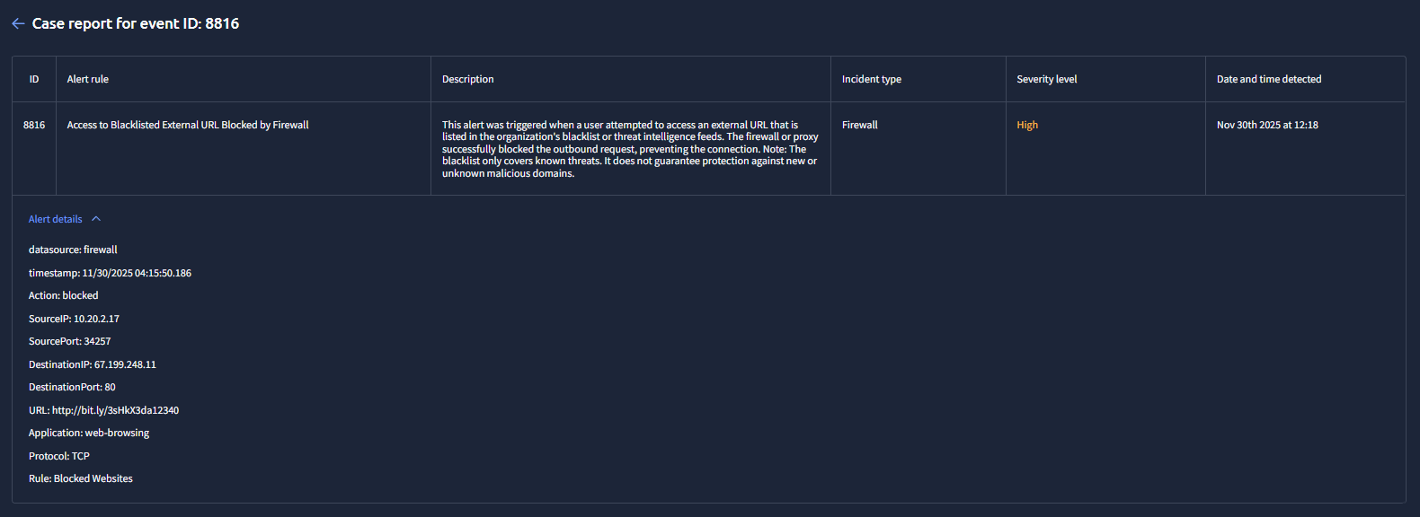
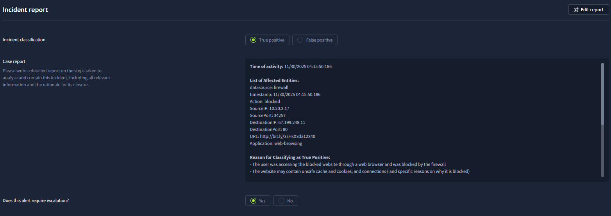
Complete IR:
Time of activity: 11/30/2025 04:15:50.186

List of Affected Entities:
datasource: firewall
timestamp: 11/30/2025 04:15:50.186
Action: blocked
SourceIP: 10.20.2.17
SourcePort: 34257
DestinationIP: 67.199.248.11
DestinationPort: 80
URL: http://bit.ly/3sHkX3da12340
Application: web-browsing

Reason for Classifying as True Positive:
- The user was accessing the blocked website through a web browser and was blocked by the firewall
- The website may contain unsafe cache and cookies, and connections ( and specific reasons on why it is blocked)

Reason for Escalating the Alert:

- The user needs to explain why the blocked website was attempted to access
- Destination port is 80 - http - unsafe

Recommended Remediation Actions:

- policy reminder
- background checking of the user ( can be an insider or shadow IT)

List of Attack Indicators:
- Attempt to access blocked website
- Destination port is 80 - http - unsafe

